# **📄 Solution Design Document**

**Client:** Family First  
 **ATS:** Eyerecruit  
 **ATS API Documentation:** [Eyerecruit API](https://joveojira.atlassian.net/browse/PRIME-53) **Business Requirements Document (BRD):** [Google Doc Link](https://docs.google.com/document/d/1yIHkplapZtEWACwNPI-fEiYInnV4rffHnx8ggh8UQ08/edit?tab=t.0#heading=h.231wls5i1ulj)  
**Prime Ticket :** [**https://joveojira.atlassian.net/browse/PRIME-53**](https://joveojira.atlassian.net/browse/PRIME-53)

## **🎯 Objective**

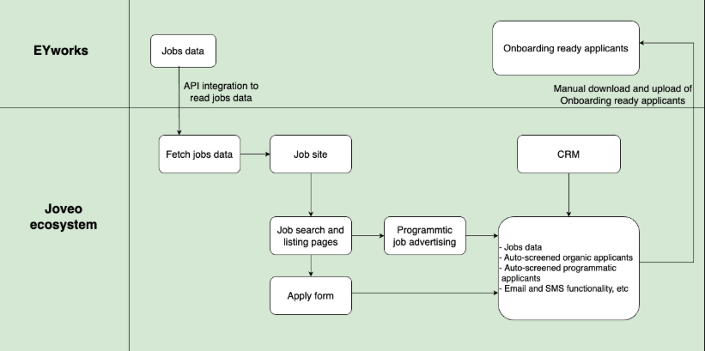

**Flow to be Followed for the implementation**

The primary objective of this project is to integrate the Eyerecruit ATS with the Family First CRM system to enable seamless tracking of:

* Job postings
* Application submissions
* Applicant data management

The goal is to ensure that jobs and applications from the ATS flow into a unified system, and applicants can be managed efficiently via the CRM.

## **🧩 Solution Flow**

### **1. Job Ingestion to Unified Database**

* **Trigger:** Job is posted or updated on Eyerecruit.
* **Mechanism:** Eyerecruit ATS API fetches job listings via scheduled jobs or webhooks.
* **Data Mapping:** Jobs are mapped to the Unified Job Schema in the Unified Database.
* **Validation:** Ensure fields such as Job Title, Location, Department, Requisition ID, and Employment Type are validated before ingestion.

### **2. Job Flow from Unified DB to Tao**

* **Sync Trigger:** Batch jobs or event-driven sync (depending on volume/frequency).
* **Transformation:** Unified job schema is transformed into Tao-specific format.
* **Transmission:** Jobs are pushed into Tao’s job repository via internal APIs.

### **3. Apply Form & Job Ingest Mojo**

* **Frontend:** Hosted apply form powered by Mojo UI framework.
* **Prefill:** Job details are prefilled from Tao DB.
* **Form Validation:** Ensures fields like resume, contact information, and pre-screening questions are filled correctly.
* **Security:** Data is encrypted in transit (HTTPS/TLS).

### **4. Applicant Submission to CRM**

* **Submission Trigger:** Upon form submission.
* **Data Collection:** Applicant details (Resume, Contact Info, Screening Questions, Source Tracking).
* **Transmission:** Submitted applications are routed to CRM through API calls.
* **Data Mapping:** Applicant fields are mapped to CRM’s schema, enabling recruiter visibility and tracking.
* **Status Update:** Applicant status (e.g., Applied, Screened, Interviewed) is maintained within CRM workflow.

## **📌 Notes**

* Authentication with Eyerecruit ATS will follow the OAuth 2.0 protocol as per API docs.
* Tao and CRM endpoints must be whitelisted for secured communication.
* Audit logging will be enabled for job sync and applicant tracking for compliance.
* Error handling and retries will be configured for job and applicant sync failures.  
    
    
    
  **📌 Effective Efforts in Days  
     
   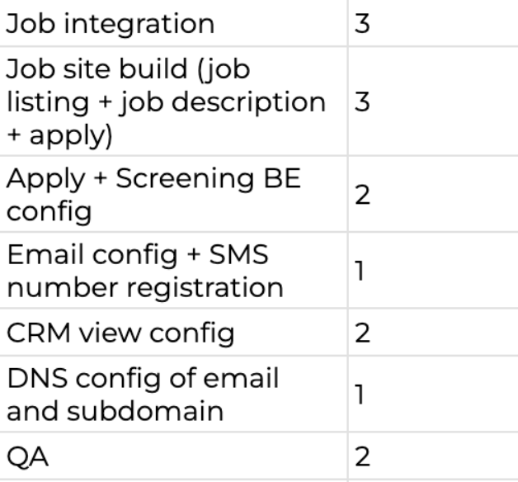**

## 

## 

## 

## 

## **📌 API Details for Integration: - Integration Type: -** Rest API

**Auth Method: -**   
 ● EachAPIrequest must be authenticated by the token provided by eyLog support team.

● APIToken needs to be sent in the “Authorization” header as Bearer

**Remain all Details: -** [**https://docs.google.com/spreadsheets/d/1hTq4XI0eAPg5guobuZjIPYQhW8U0wHZdAxV2TVwZxHM/edit?gid=1533463013#gid=1533463013**](https://docs.google.com/spreadsheets/d/1hTq4XI0eAPg5guobuZjIPYQhW8U0wHZdAxV2TVwZxHM/edit?gid=1533463013#gid=1533463013)